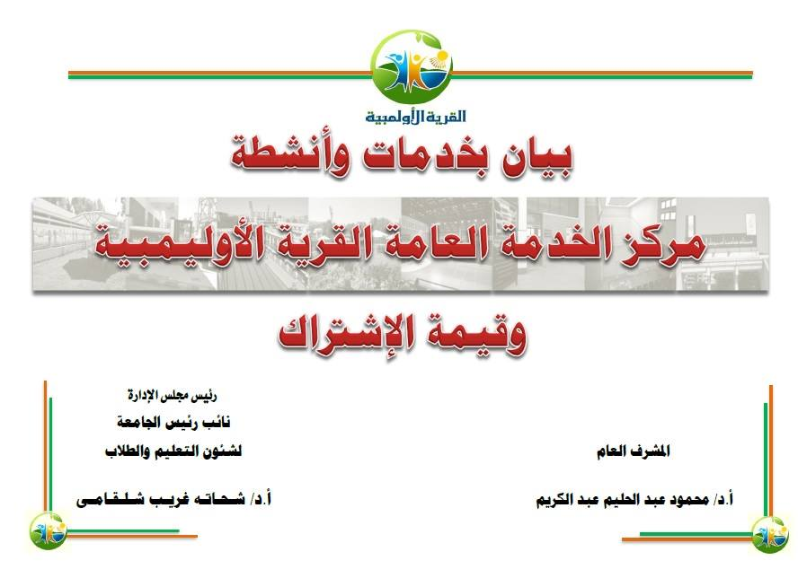

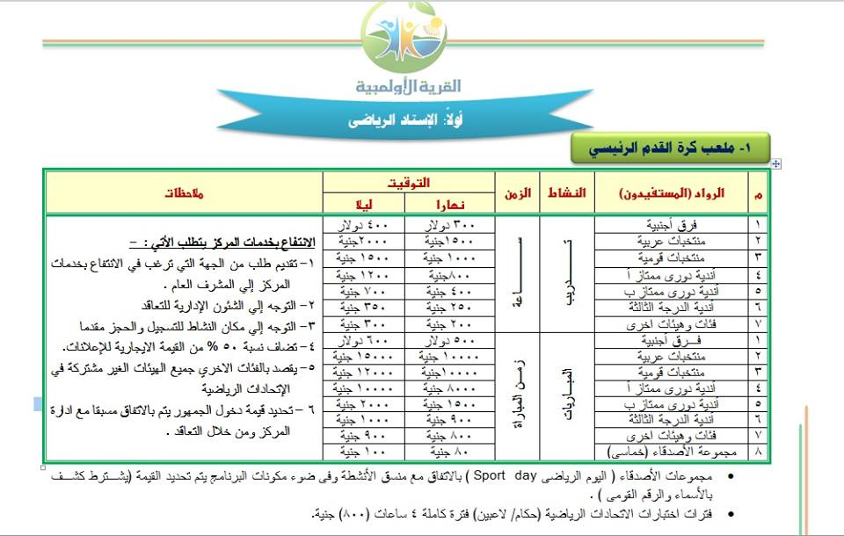

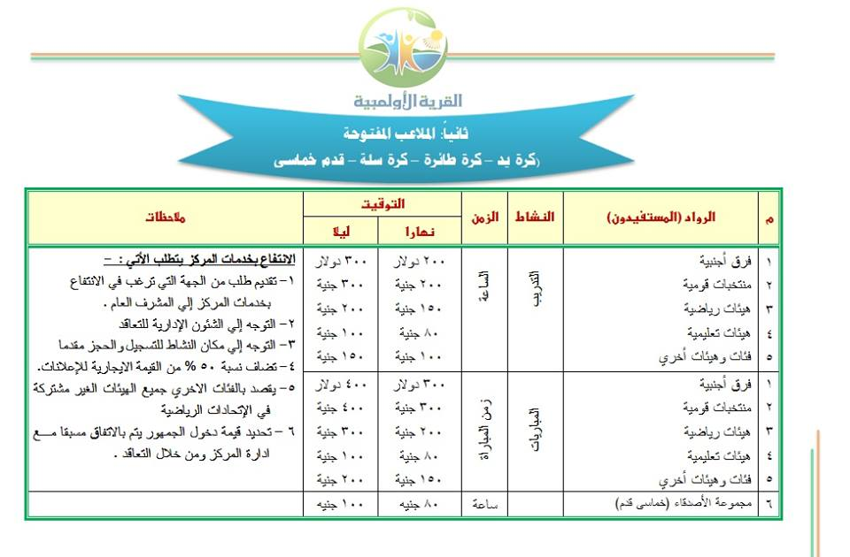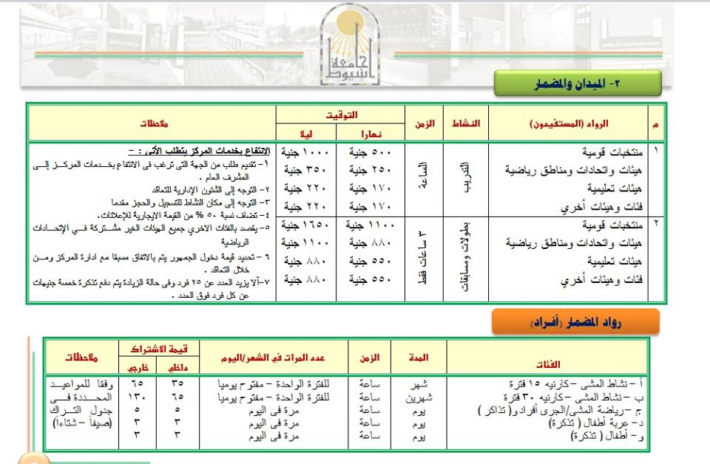

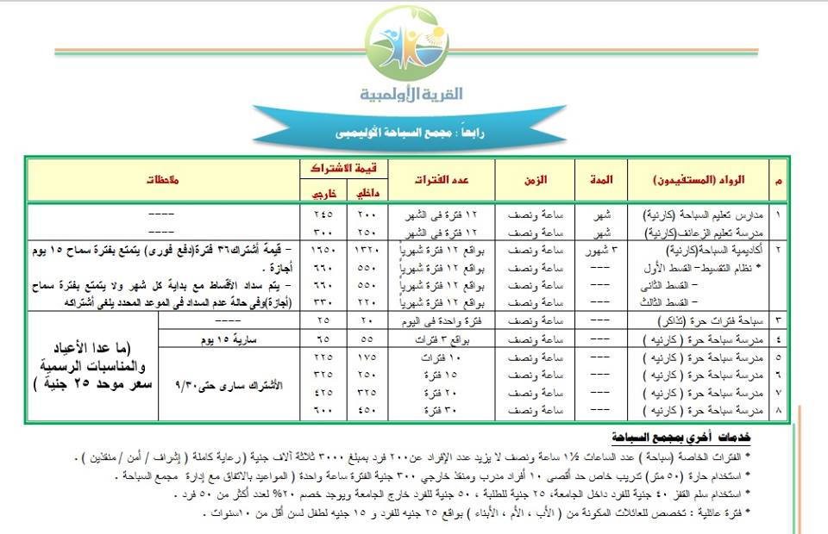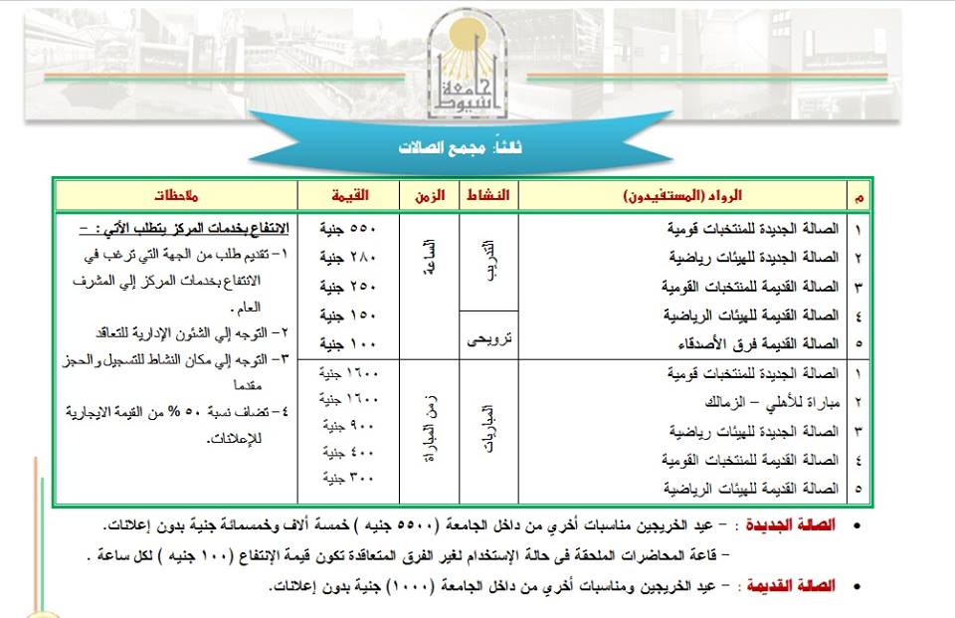jjjmn

,,

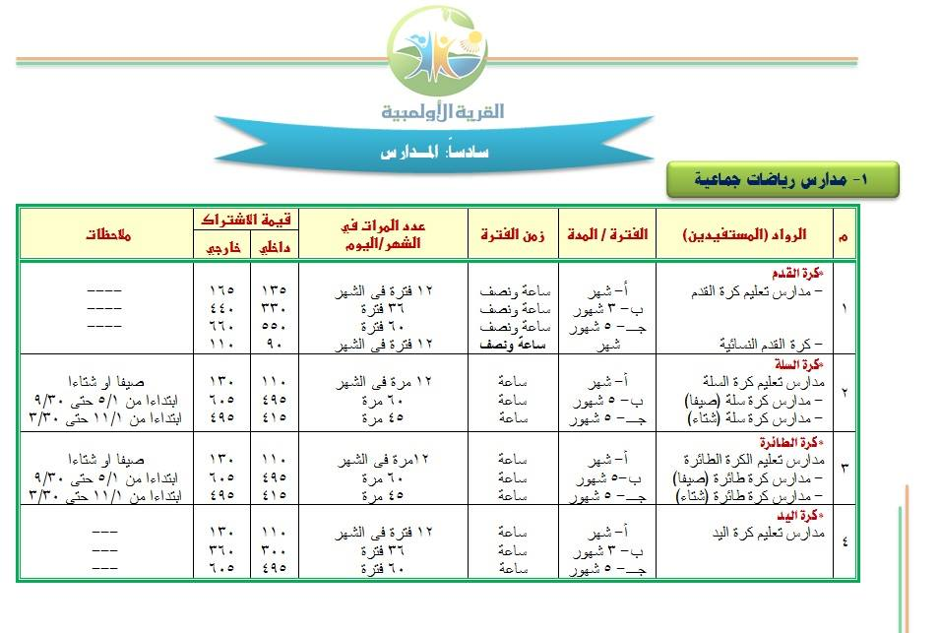

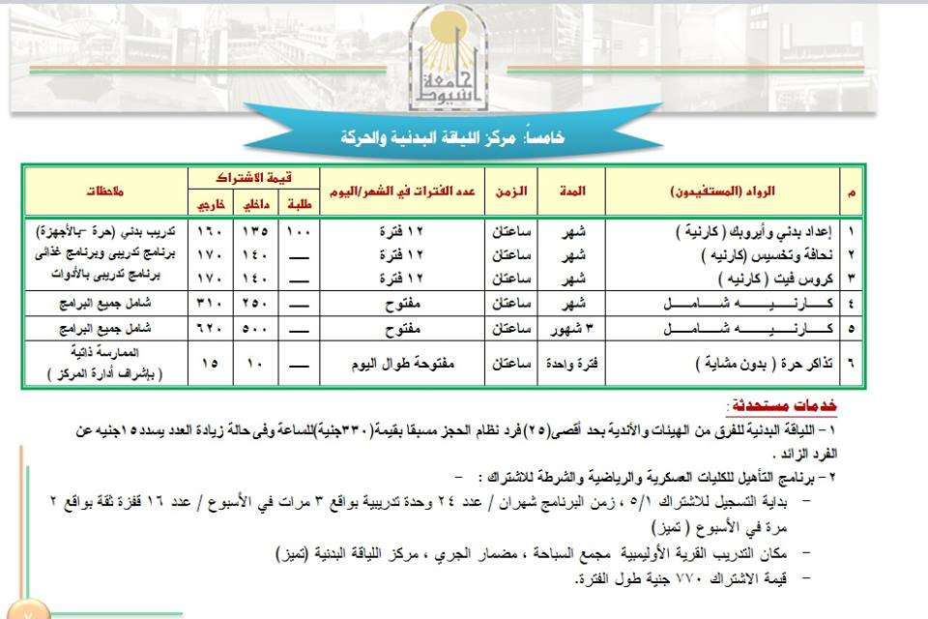aaaaaaaaa

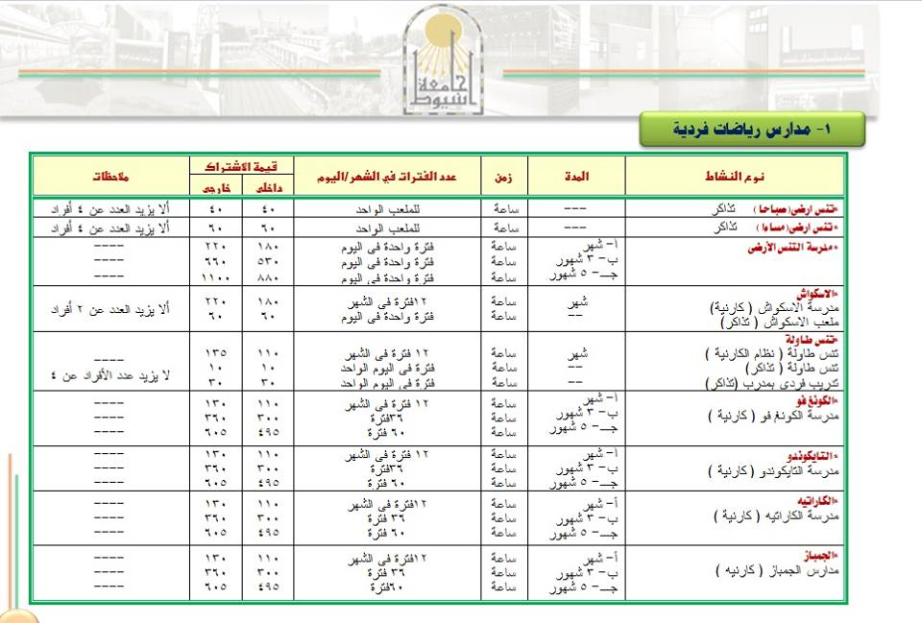

aaaa

aa

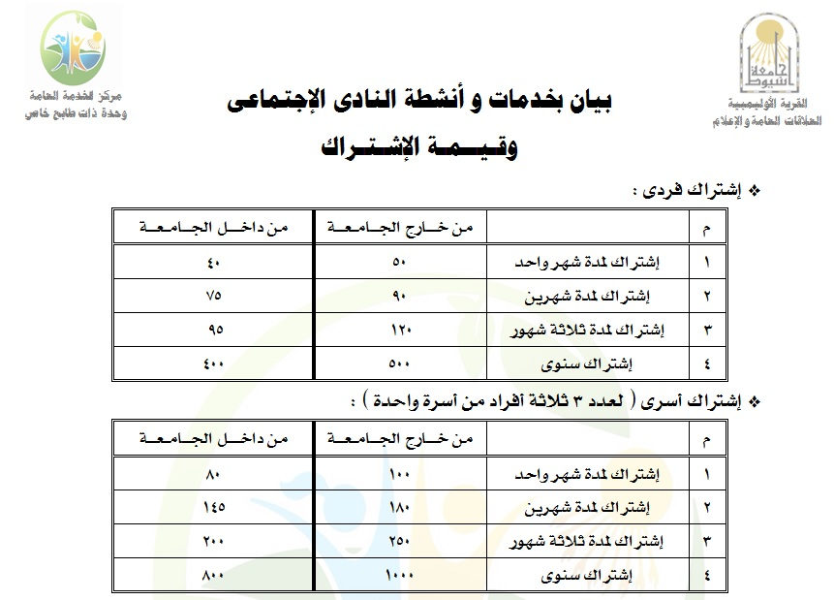

|  |  |
| --- | --- |
| http://www.aun.edu.eg/olympic_village/images/bb1.jpg | http://www.aun.edu.eg/olympic_village/images/bb2.jpg |
| [مجمع السباحة الأولـمبي](http://www.aun.edu.eg/olympic_village/images/sector11.jpg) | [استاد رياضي دولي](http://www.aun.edu.eg/olympic_village/images/sector12.jpg) |
| http://www.aun.edu.eg/olympic_village/images/bb3.jpg | http://www.aun.edu.eg/olympic_village/images/bb4.jpg |
| [مجمع الصالات](http://www.aun.edu.eg/olympic_village/images/sector13.jpg) | [مجمع الاسكواش](http://www.aun.edu.eg/olympic_village/images/sector14.jpg) |
| http://www.aun.edu.eg/olympic_village/images/bb5.jpg | http://www.aun.edu.eg/olympic_village/images/bb6.jpg |
| [صالة الالعاب القديمة](http://www.aun.edu.eg/olympic_village/images/sector15.jpg) | [مجمع التنس الارضى](http://www.aun.edu.eg/olympic_village/images/sector16.jpg) |
| http://www.aun.edu.eg/olympic_village/images/bb7.jpg | http://www.aun.edu.eg/olympic_village/images/bb8.jpg |
| [مجمع الملاعب المفتوحة](http://www.aun.edu.eg/olympic_village/images/sector17.jpg) | [مركز اللياقة البدنية والحركية](http://www.aun.edu.eg/olympic_village/images/sector18.jpg) |
| http://www.aun.edu.eg/olympic_village/images/bb9.jpg | http://www.aun.edu.eg/olympic_village/images/bb10.jpg |
| [قاعات الأيروبك](http://www.aun.edu.eg/olympic_village/images/sector19.jpg) | [قاعة المناسبات](http://www.aun.edu.eg/olympic_village/images/sector110.jpg) |
| http://www.aun.edu.eg/olympic_village/images/bb11.jpg | http://www.aun.edu.eg/olympic_village/images/bb12.jpg |
| [حديقة النادى الإجتماعى](http://www.aun.edu.eg/olympic_village/images/sector111.jpg) | [قاعات بهو الرواد](http://www.aun.edu.eg/olympic_village/images/sector112.jpg) |
| http://www.aun.edu.eg/olympic_village/images/bb13.jpg | http://www.aun.edu.eg/olympic_village/images/bb14.jpg |
| [الشئون الإدارية وخدمة الرواد](http://www.aun.edu.eg/olympic_village/images/sector113.jpg) | [مركز التربية الحركية للأطفال](http://www.aun.edu.eg/olympic_village/images/sector114.jpg) |
|  |  |
| [ملحق النادى الإجتماعى الجديد (تراس مجمع السباحة)](http://www.aun.edu.eg/olympic_village/sector17.php) |  |