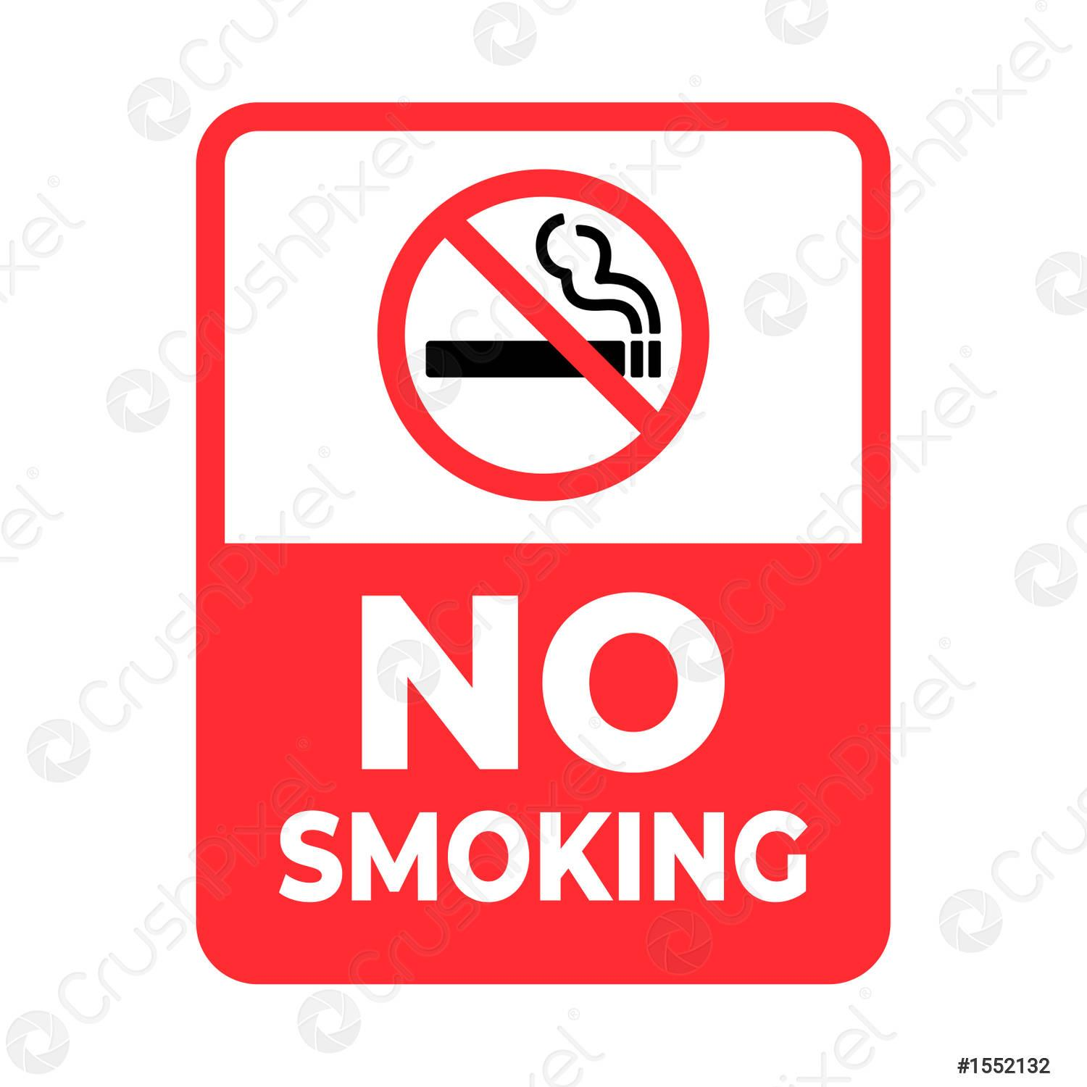

Assiut University has a rule for smoke free campus. Assiut University believes that comprehensive Smoke-Free Campus Policies make it easy for people to resist and quit smoking and can have a tremendous impact on the health of an entire campus community. Therefore, Assiut University has prohibited smoking on campus in accordance to the UN development Goals.

After reviewing Law No.154 of 2007 , which was issued by the presidency of the Republic on Jumada al-Akher 6, 1428 AH corresponding to June 21 , 2007 as Assuit University seeks, through its various departments, to provide the highest quality services to improve and develop the general appearance of the University cities and it was noted some people smoke inside the buildings and this is inconsistent with the efforts made by the university in preserving its civilized appearance, on it and in order to preserve the health of everyone and because of the public interest in it. You will apply the penalty for violating this system, and accordingly the following was issued:
Smoking is strictly prohibited in all its forms in various health and educational facilities and government agencies, as the director in charge of these places is obligated to take measures to ensure that smoking is prohibited in them, and breaching this obligation is punished A fine of not less than one thousand Egyptian pounds and not more than twenty thousand Egyptian pounds. The smoker is also punished with a fine of not less than fifty thousand pounds and not more than hundred thousand pounds.

