Title: Prognostic and diagnostic roles of some non-classic biomarkers in pediatric pneumonia
Running title: Non-Classic Biomarkers in Pediatric Pneumonia: Prognostic and Diagnostic Insights
Abstract
Background: Pediatric pneumonia remains a leading cause of childhood morbidity and mortality worldwide. Traditional biomarkers have limitations in predicting disease severity and outcomes. This study evaluated the diagnostic and prognostic value of non-classic biomarkers in pediatric pneumonia.
Objective: To assess the utility of neutrophil CD64 expression, neutrophil-to-monocyte CD64 ratio, neutrophil-to-lymphocyte CD64 ratio in pediatric pneumonia diagnosis and prognosis.
Methods: A case-control study was conducted at Assiut University Children's Hospital including 60 children with pneumonia and 60 age-matched healthy controls. Clinical assessments, routine laboratory investigations, and flow cytometric analysis were performed. Cases were evaluated using the Clinical Respiratory Score and followed for outcomes including ICU admission, mechanical ventilation, and mortality. Receiver operating characteristic (ROC) curve analysis determined diagnostic performance.
Results: The non-classic biomarker showed significant differences between cases and controls (p<0.001). Neutrophil CD64 (692.67±326.26 vs. 359.84±57.48), and CD64 ratios were significantly elevated in cases. Biomarkers correlated significantly with disease severity, prolonged hospitalization, ICU admission, and mechanical ventilation. Fatal cases demonstrated markedly elevated inflammatory markers. ROC analysis revealed excellent diagnostic performance, with neutrophil-to-lymphocyte CD64 ratio showing superior accuracy (AUC=0.97, sensitivity=90%, specificity=99%).
Conclusion: Non-classic biomarkers demonstrate significant diagnostic and prognostic utility in pediatric pneumonia. These findings support their integration into clinical practice for improved risk stratification, treatment decision-making, and outcome prediction in children with pneumonia.
Keywords: Pediatric pneumonia; CD64; Biomarkers; Prognosis; Diagnosis

Introduction
Pediatric pneumonia remains a leading cause of morbidity and mortality among children worldwide, accounting for approximately 15% of all deaths in children under five years of age. Despite advances in diagnostic imaging and laboratory techniques, early identification of pneumonia severity and accurate prognostic assessment continue to challenge clinicians, particularly in resource-limited settings where rapid decision-making is crucial for optimal patient outcomes [1].
Traditional biomarkers such as C-reactive protein (CRP), procalcitonin, and white blood cell count, while widely used, demonstrate suboptimal sensitivity and specificity for distinguishing pneumonia severity and predicting clinical outcomes in pediatric populations [2]. The heterogeneous clinical presentation of pediatric pneumonia, coupled with the limitations of conventional chest radiography in early disease stages, necessitates the identification of more precise diagnostic and prognostic tools [3].
Recent advances in immunology have highlighted the potential of non-classic biomarkers that reflect specific aspects of the host immune response to respiratory infections. Neutrophil CD64 expression, a high-affinity Fc receptor upregulated during bacterial infections, offers potential for distinguishing infectious from non-infectious inflammatory conditions [5].
The clinical utility of this non-classic biomarker in pediatric pneumonia diagnosis, severity assessment, and outcome prediction remains inadequately characterized. Furthermore, their intercorrelation and relative performance compared to traditional inflammatory markers require systematic evaluation to determine their potential integration into clinical practice.

Patients and Methods
Study Design and Setting
This case-control study was conducted at Assiut University Children's Hospital (AUCH), specifically within the Chest and Emergency Unit, over a two-year period. The study protocol was approved by the institutional review board, and written informed consent was obtained from parents or guardians of all participants.
Study Population
Inclusion Criteria
Children aged one month to five years presenting with community-acquired pneumonia (CAP) at AUCH were enrolled as cases. Controls comprised age- and sex-matched healthy children without CAP.
Exclusion Criteria
Patients with severe sepsis, localized infections (endocarditis, empyema), autoimmune diseases, liver cirrhosis, or those receiving immunosuppressive therapy were excluded to maintain study homogeneity.
Sample Size
A total of 120 participants were recruited: 60 children with pneumonia (cases) and 60 healthy controls matched by age and sex. Sample size was calculated based on anticipated effect sizes and statistical power considerations for detecting significant between-group differences.
Data Collection
Clinical Assessment
Comprehensive medical history and physical examination were performed for all participants. Clinical data included presenting symptoms, illness duration, vaccination status, hospital length of stay, intensive care unit (ICU) admission, mechanical ventilation requirements, and clinical outcomes.
Disease Severity Assessment
Respiratory distress severity was evaluated using the Clinical Respiratory Score (CRS), incorporating six parameters: respiratory rate, auscultation findings, accessory muscle use, mental status, oxygen saturation, and color. Patients were classified as mild (≤3), moderate (4-7), or severe (8-12) based on total scores [7].
Laboratory Investigations
Routine Laboratory Tests
Complete blood count, C-reactive protein (CRP), and chest X-ray were performed for all participants. Blood samples were collected in EDTA-anticoagulated tubes for hematological analysis.
Flow Cytometric Analysis
Neutrophil CD64 expression and was assessed using flow cytometry from 50μl whole blood samples. Cell differentiation was achieved through forward and side scatter gating, following standardized protocols.
Biomarker Analysis
Neutrophil-to-monocyte CD64 ratio and neutrophil-to-lymphocyte CD64 ratio were calculated from flow cytometric data.
Statistical Analysis
Statistical analysis was performed using SPSS version 20.0 (SPSS Inc., Chicago, IL, USA). Continuous variables were expressed as mean ± standard deviation for normally distributed data or median and range for non-normally distributed data. Categorical variables were presented as frequencies and percentages.
Between-group comparisons were performed using Student's t-test for normally distributed continuous variables and Mann-Whitney U test for non-normally distributed data. Chi-square test or Fisher's exact test (when expected frequency <5) was used for categorical variables. One-way ANOVA was employed for multiple group comparisons. Correlation analysis was conducted using Pearson correlation coefficient. Receiver operating characteristic (ROC) curve analysis was performed to evaluate the diagnostic performance of biomarkers for predicting pediatric pneumonia. Statistical significance was set at p<0.05 (two-tailed).
Ethical Considerations
The study was conducted in accordance with the Declaration of Helsinki. All patient data remained strictly confidential, and comprehensive information regarding study procedures was provided to guardians prior to obtaining informed consent.

Results
Table 1 shows the demographic characteristics, clinical features, laboratory parameters, and non-classic biomarkers among pediatric pneumonia cases and controls. Cases had significantly higher rural residence (73% vs. 37%, p<0.001) and lower vitamin supplementation (46.6% vs. 73%, p=0.002) compared to controls. Vital signs demonstrated significant differences, with cases showing tachycardia (150.97±25.81 vs. 139.00±9.19 beats/min, p=0.001), tachypnea (47.83±9.89 vs. 44.07±8.80 cycles/min, p=0.03), fever (38.23±0.48°C vs. 37.50±0.46°C, p<0.001), and hypoxemia (88.98±7.33% vs. 95.90±1.54%, p<0.001). Hematological parameters showed leukocytosis in cases (WBCs 14233.08±4698.30/L vs. 9993.58±3287.02/L, p<0.001) with thrombocytopenia (317666.66±104715.05/L vs. 468050.00±221943.75/L, p<0.001). CRP was markedly elevated in cases (45.06±44.31 mg/L vs. 3.60±8.58 mg/L, p<0.001). Hypoproteinemia and hypoalbuminemia were observed in pneumonia patients (p<0.001 and p=0.004, respectively).
Among non-classic biomarkers, Neutrophil CD64-FITC expression and CD64 ratios (neutrophil-to-monocyte and neutrophil-to-lymphocyte) were significantly higher in cases (all p<0.001). Nearly half of pneumonia cases required ICU admission (46.7%), with 41.6% requiring mechanical ventilation and 6.7% mortality.
Table 1. Demographic, Clinical Characteristics, Laboratory Parameters and Non-Classic Biomarkers among Pediatric Pneumonia Cases and Controls
Characteristic | Controls (n=60) | Cases (n=60) | p-value
Demographic characteristics
Gender, n (%) |  |  | 0.202
Male | 42 (70.0) | 47 (78.3)
Female | 18 (30.0) | 13 (21.7)
Age in months, mean ± SD | 38.13 ± 10.96 | 37.27 ± 11.49 | 0.676
Residence, n (%) |  |  | <0.001*
Urban | 38 (63.0) | 16 (27.0)
Rural | 22 (37.0) | 44 (73.0)
Nutritional history, n (%) |  |  | 0.662
Breast feeding | 37 (61.6) | 36 (60.0)
Artificial | 18 (30.0) | 16 (26.6)
Mixed | 5 (8.4) | 8 (13.4)
Vitamin supplementation, n (%) |  |  | 0.002*
Yes | 44 (73.0) | 28 (46.6)
No | 16 (27.0) | 32 (53.4)
Anthropometric measurements, mean ± SD
Weight (kg) | 15.82 ± 2.74 | 15.33 ± 2.82 | 0.335
Length (m) | 0.88 ± 0.074 | 0.87 ± 0.084 | 0.341
Body mass index | 20.11 ± 1.59 | 20.14 ± 1.89 | 0.902
Vital signs, mean ± SD
Heart rate (beats/min) | 139.00 ± 9.19 | 150.97 ± 25.81 | 0.001*
Respiratory rate (cycles/min) | 44.07 ± 8.80 | 47.83 ± 9.89 | 0.030*
Temperature (°C) | 37.50 ± 0.46 | 38.23 ± 0.48 | <0.001*
Oxygen saturation (%) | 95.90 ± 1.54 | 88.98 ± 7.33 | <0.001*
Systolic blood pressure (mmHg) | 89.92 ± 10.51 | 73.92 ± 20.54 | <0.001*
Diastolic blood pressure (mmHg) | 56.67 ± 7.73 | 48.67 ± 16.20 | 0.001*
Hematological parameters, mean ± SD
WBCs (/L) | 9993.58 ± 3287.02 | 14233.08 ± 4698.30 | <0.001*
Lymphocytes (%) | 34.20 ± 12.35 | 31.96 ± 8.12 | 0.244
Neutrophils (%) | 54.36 ± 15.89 | 57.57 ± 6.92 | 0.153
Monocytes (%) | 6.36 ± 1.91 | 5.70 ± 0.74 | 0.014
RBCs (million/L) | 3.88 ± 0.86 | 3.94 ± 0.44 | 0.680
Hemoglobin (g/L) | 9.48 ± 0.88 | 9.71 ± 1.57 | 0.327
Hematocrit value (%) | 27.59 ± 3.46 | 30.60 ± 4.26 | <0.001*
MCV | 84.50 ± 5.80 | 77.90 ± 9.04 | <0.001*
MCH | 28.40 ± 1.19 | 24.56 ± 3.27 | <0.001*
MCHC | 33.35 ± 1.94 | 31.54 ± 1.86 | <0.001*
Platelets (/L) | 468050.00 ± 221943.75 | 317666.66 ± 104715.05 | <0.001*
Biochemical parameters, mean ± SD
BUN (mmol/L) | 3.61 ± 0.45 | 4.23 ± 2.76 | 0.880
Creatinine (mg/dl) | 0.25 ± 0.085 | 0.32 ± 0.13 | 0.001*
Na (mmol/L) | 137.85 ± 2.19 | 140.23 ± 8.57 | 0.041*
K (mmol/L) | 4.93 ± 0.68 | 4.52 ± 1.10 | 0.017*
Ca (mg/dl) | 8.77 ± 0.27 | 8.81 ± 0.75 | 0.689
Total proteins (g/dL) | 6.81 ± 1.16 | 5.70 ± 1.11 | <0.001*
Albumin (g/dL) | 3.88 ± 0.33 | 3.56 ± 0.77 | 0.004
ALT (U/L) | 23.33 ± 7.60 | 28.00 ± 21.20 | 0.105
AST (U/L) | 36.65 ± 30.75 | 39.02 ± 16.41 | 0.600
ALP (U/L) | 315.85 ± 137.61 | 274.00 ± 340.39 | 0.379
Total bilirubin (mg/dL) | 0.42 ± 0.28 | 0.38 ± 0.23 | 0.372
Direct bilirubin (mg/dL) | 0.17 ± 0.15 | 0.14 ± 0.14 | 0.220
C-reactive protein (mg/L) | 3.60 ± 8.58 | 45.06 ± 44.31 | <0.001*
Clinical presentation in cases, n (%)
Fever | - | 50 (83.0) | -
Difficulty of breathing | - | 45 (75.0) | -
Dry cough | - | 44 (73.0) | -
Wet cough | - | 16 (27.0) | -
Previous hospital admission | - | 20 (33.3) | -
Previous admission to NICU | - | 8 (13.0) | -
Clinical respiratory score, n (%)
Mild (≤3) | - | 14 (23.4) | -
Moderate (4-7) | - | 20 (33.3) | -
Severe (8-12) | - | 26 (43.3) | -
Chest X-ray findings, n (%)
Bronchopneumonia | - | 40 (67.7) | -
Lobar pneumonia | - | 20 (33.3) | -
Outcomes, n (%)
ICU admission | - | 28 (46.7) | -
Mechanical ventilation | - | 25 (41.6) | -
Mortality | - | 4 (6.7) | -
Hematological parameters
WBCs (/L) | 9993.58 ± 3287.02 | 14233.08 ± 4698.30 |  | <0.001*
Neutrophils (%) | 54.36 ± 15.89 | 57.57 ± 6.92 |  | 0.153
Lymphocytes (%) | 34.20 ± 12.35 | 31.96 ± 8.12 |  | 0.244
Monocytes (%) | 6.36 ± 1.91 | 5.70 ± 0.74 |  | 0.014
Hemoglobin (g/L) | 9.48 ± 0.88 | 9.71 ± 1.57 |  | 0.327
Platelets (/L) | 468050.00 ± 221943.75 | 317666.66 ± 104715.05 |  | <0.001*
Biochemical parameters
C-reactive protein (mg/L) | 3.60 ± 8.58 | 45.06 ± 44.31 |  | <0.001*
Total proteins (g/dL) | 6.81 ± 1.16 | 5.70 ± 1.11 |  | <0.001*
Albumin (g/dL) | 3.88 ± 0.33 | 3.56 ± 0.77 |  | 0.004*
Non-classic biomarkers
Neutrophils CD64-FITC | 359.84 ± 57.48 | 692.67 ± 326.26 |  | <0.001*
Neutrophils CD64-FITC / Monocytes CD64-FITC ratio | 0.34 ± 0.14 | 1.03 ± 1.24 |  | <0.001*
Neutrophils CD64-FITC / Lymphocytes CD64-FITC ratio | 4.58 ± 1.93 | 28.66 ± 26.98 |  | <0.001*
CRP: C-reactive protein; WBCs: white blood cells; RBCs: red blood cells; MCV: mean corpuscular volume; MCH: mean corpuscular hemoglobin; MCHC: mean corpuscular hemoglobin concentration; BUN: blood urea nitrogen; ALT: alanine aminotransferase; AST: aspartate aminotransferase; ALP: alkaline phosphatase; NICU: neonatal intensive care unit; ICU: intensive care unit.
P-values were calculated using chi-square test for categorical variables and Student's t-test for continuous variables. *P<0.05 was considered statistically significant.

Table 2 demonstrates significant associations between biomarkers and clinical outcomes in pediatric pneumonia. Patients with prolonged hospitalization (>1 week) showed significantly elevated CRP and increased CD64 ratios. ICU admission was associated with higher inflammatory markers, particularly CRP (64.74±51.32 vs. 27.84±28.07 mg/L, p=0.001) . Similarly, mechanical ventilation requirement correlated with elevated CRP (p=0.001) and increased neutrophil/monocyte CD64 ratio (p=0.020), indicating enhanced neutrophil activation in critically ill patients.
Table 2. Association of Biomarkers with Disease Severity and Clinical Outcomes in Pediatric Pneumonia Cases
Biomarker | Hospital Stay Duration |  |  | ICU Admission |  |  | Mechanical Ventilation
 | ≤1 week (n=29) | >1 week (n=31) | p | No (n=32) | Yes (n=28) | p | No (n=35) | Yes (n=25) | p
CRP (mg/L) | 23.77±24.01 | 64.98±49.76 | <0.001* | 27.84±28.07 | 64.74±51.32 | 0.001* | 28.91±27.07 | 67.67±53.63 | 0.001*
Neutrophils CD64-FITC | 612.99±223.72 | 767.21±388.27 | 0.063 | 618.69±216.78 | 777.23±405.89 | 0.060 | 627.97±209.78 | 783.26±429.75 | 0.105
Neutrophils/Monocytes CD64 ratio | 0.69±0.51 | 1.35±1.59 | 0.036* | 0.71±0.49 | 1.39±1.67 | 0.031* | 0.72±0.47 | 1.46±1.76 | 0.020*
Neutrophils/Lymphocytes CD64 ratio | 19.14±14.89 | 36.38±32.88 | 0.012* | 23.33±20.22 | 33.44±32.71 | 0.150 | 24.07±19.56 | 33.63±34.61 | 0.179
CRP: C-reactive protein; CD64: cluster of differentiation 64; FITC: fluorescein isothiocyanate; ICU: intensive care unit.
P-values were calculated using Student's t-test for independent samples. *P<0.05 was considered statistically significant.

Table 3 reveals a progressive relationship between biomarker levels and disease severity as measured by Clinical Respiratory Score. CRP levels increased significantly across severity groups (13.24±26.29 to 66.32±52.95 mg/L, p=0.001), while neutrophil CD64 and CD64 ratios showed results toward higher values in severe cases, these differences did not reach statistical significance.
Table 3. Biomarkers According to Clinical Respiratory Score Severity in Pediatric Pneumonia Cases
Biomarker | Mild (≤3) (n=11) | Moderate (4-7) (n=22) | Severe (8-12) (n=27) | p-value
CRP (mg/L) | 13.24±26.29 | 34.88±22.28 | 66.32±52.95 | 0.001*
Neutrophils CD64-FITC | 581.86±270.37 | 651.04±172.41 | 771.74±419.85 | 0.203
Neutrophils/Monocytes CD64 ratio | 0.49±0.27 | 0.81±0.54 | 1.41±1.70 | 0.066
Neutrophils/Lymphocytes CD64 ratio | 18.53±23.08 | 25.87±17.04 | 33.70±33.80 | 0.265
CRP: C-reactive protein; CD64: cluster of differentiation 64; FITC: fluorescein isothiocyanate; ICU: intensive care unit.
P-values were calculated using Student's t-test for two-group comparisons and one-way ANOVA for multiple group comparisons. P<0.05 was considered statistically significant.

Table 4 demonstrates strong intercorrelations among all biomarkers in both pneumonia cases and the entire study population. CRP showed the strongest correlations with other inflammatory markers, particularly with neutrophil/lymphocyte CD64 ratio (r=0.724 in cases, r=0.791 in total population). Notably, with CRP showing the strongest inverse relationship (r=-0.738 in cases). The correlations were generally stronger in the entire study population, likely due to the wider range of values when including healthy controls.
Table 4. Correlations among Biomarkers in Pediatric Pneumonia Cases and Entire Study Population
Biomarker Pairs | Cases Only (n=60) |  | Entire Study Population (n=120)
 | r | p | r | p
CRP correlations
CRP and Neutrophils CD64-FITC | 0.667** | <0.001 | 0.760** | <0.001
CRP and Neutrophils/Monocytes CD64 ratio | 0.642** | <0.001 | 0.687** | <0.001
CRP and Neutrophils/Lymphocytes CD64 ratio | 0.724** | <0.001 | 0.791** | <0.001
Neutrophils CD64-FITC correlations
Neutrophils CD64-FITC and Neutrophils/Monocytes CD64 ratio | 0.681** | <0.001 | 0.724** | <0.001
Neutrophils CD64-FITC and Neutrophils/Lymphocytes CD64 ratio | 0.544** | <0.001 | 0.679** | <0.001
CD64 ratio correlations
Neutrophils/Monocytes CD64 ratio and Neutrophils/Lymphocytes CD64 ratio | 0.566** | <0.001 | 0.643** | <0.001
CRP: C-reactive protein; CD64: cluster of differentiation 64; FITC: fluorescein isothiocyanate..
**Correlation is significant at the 0.01 level (2-tailed). Pearson correlation coefficient was used for analysis.

Figure 1 demonstrates the diagnostic performance of four biomarkers for pediatric pneumonia diagnosis through ROC curve analysis. The neutrophil-to-lymphocyte CD64 ratio exhibited superior diagnostic accuracy (AUC=0.97) with optimal sensitivity (90%) and specificity (99%) at a cut-off of 7.3. Neutrophil CD64-FITC and neutrophil-to-monocyte CD64 ratio both showed excellent performance (AUC=0.91) with high specificity (85-92%). CRP demonstrated good diagnostic utility (AUC=0.86-0.89) with balanced sensitivity and specificity.

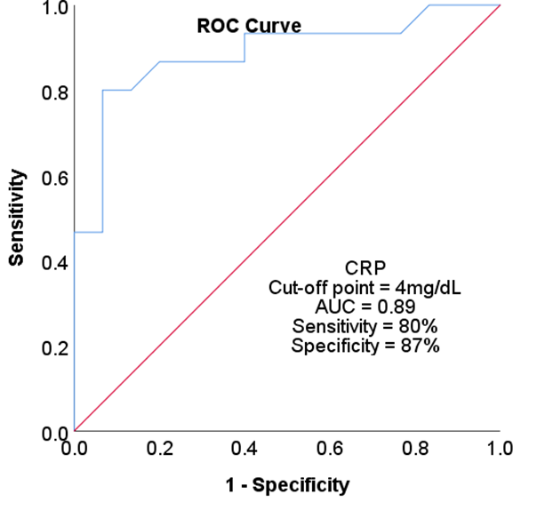  A | 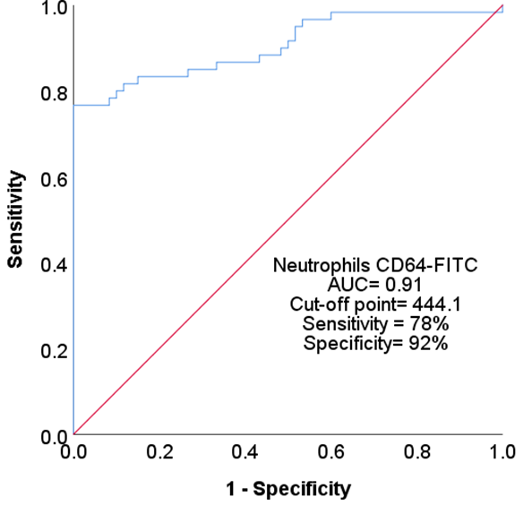  B | 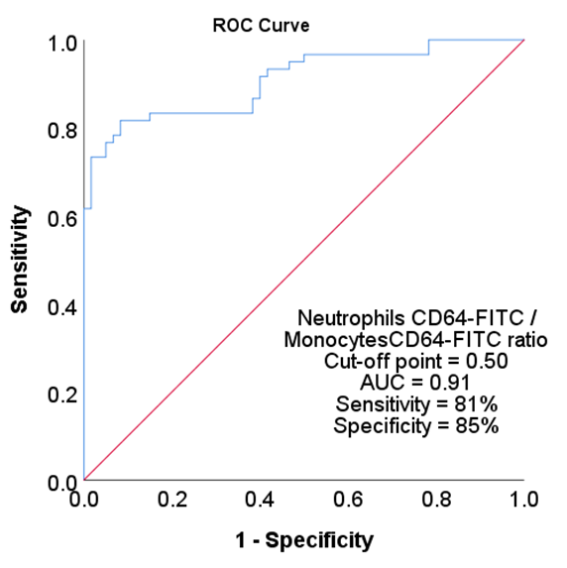  C
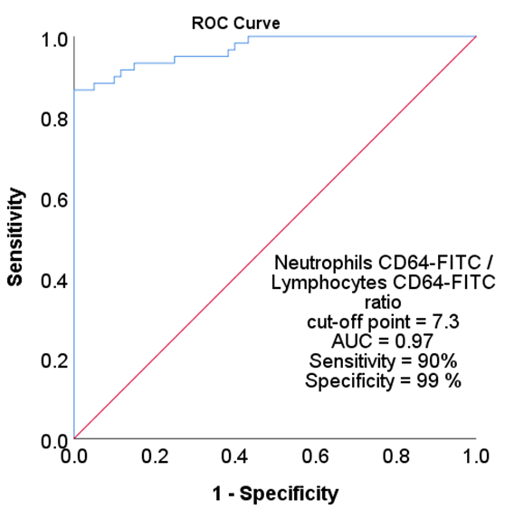
D
Figure 1. ROC Curve Analysis of Non-Classic Biomarkers for Diagnosing Pediatric Pneumonia
(A) C-reactive protein, (B)Neutrophils CD64-FITC, (C) Neutrophils CD64-FITC/Monocytes CD64-FITC ratio, (D) Neutrophils CD64-FITC/Lymphocytes CD64-FITC ratio.

Discussion
The present study evaluated non-classic biomarkers in pediatric pneumonia, demonstrating their significant potential for diagnosis and prognosis assessment. Our findings contribute to the growing body of evidence supporting the clinical utility of immune response markers beyond traditional inflammatory indicators.

In our study, Neutrophil CD64-FITC expression was markedly elevated in cases, with excellent diagnostic accuracy (sensitivity 78%, specificity 92%, AUC 0.91). The neutrophil-to-lymphocyte CD64 ratio demonstrated exceptional performance (sensitivity 90%, specificity 99%, AUC 0.97), representing the highest diagnostic accuracy among all tested biomarkers. This high-affinity Fc receptor upregulation reflects neutrophil activation during bacterial infections, consistent with studies by Ito and Ishida (2020) showing CD64's utility in distinguishing bacterial from viral pneumonia in children [5].

Our study demonstrated strong correlations between biomarker levels and clinical severity. Patients requiring ICU admission showed significantly higher CRP (64.74±51.32 vs. 27.84±28.07 mg/L, p=0.001). Similarly, mechanical ventilation requirement correlated with elevated inflammatory markers, particularly the neutrophil/monocyte CD64 ratio (p=0.020). These associations support findings by Florin et al. (2020), who demonstrated that elevated biomarkers correlate with severe complications in pediatric community-acquired pneumonia [6]. The relationship between mechanical ventilation and mortality observed in our study aligns with research by Meliyanti et al. (2021) and Amin et al. (2023), who identified significant mortality risks associated with mechanical ventilation in pediatric pneumonia patients [8,9].
The Clinical Respiratory Score analysis revealed a progressive relationship between biomarker levels and disease severity. CRP levels increased significantly across severity groups (13.24±26.29 to 66.32±52.95 mg/L, p=0.001).
The strong positive correlations observed between inflammatory markers CRP-neutrophil CD64: r=0.667, p<0.001) suggest coordinated immune responses during pneumonia. Our correlation findings support the work of Williams et al. (2024), who identified transcriptomic biomarkers associated with disease severity in childhood pneumonia [12].
Our findings revealed significant hematological changes, including elevated WBC counts and thrombocytopenia in pneumonia cases. These alterations align with studies by Güven and Kışlal (2022) and Ruan et al. (2024), who demonstrated significant differences in hematological markers between children with bacterial pneumonia and other respiratory conditions [13,14]. The biochemical changes observed, including hypoproteinemia and elevated CRP levels, support the inflammatory response patterns described by Wrotek et al. (2022) in their analysis of serum inflammatory markers in pediatric pneumonia [15].
While CRP demonstrated good diagnostic performance (sensitivity 80%, specificity 87%, AUC 0.89), consistent with findings by Ayaz et al. (2024) who reported similar diagnostic accuracy for CRP in pediatric pneumonia [18], the neutrophil-to-lymphocyte CD64 ratio showed superior accuracy. This finding supports the advocacy by Principi and Esposito (2017) for multi-marker approaches in pediatric pneumonia diagnosis [17]. The integration of biomarkers into prediction models, as demonstrated by Ramgopal et al. (2023), shows promise for improving diagnostic accuracy [18].
Our findings regarding reduced vitamin supplementation in cases (46.6% vs. 73%, p=0.002) align with studies by Labib et al. (2021) and Saied et al. (2022), who demonstrated the protective effects of vitamin D, zinc, and vitamin A supplementation in pediatric pneumonia patients [19,20]. The higher rural residence prevalence in cases (73% vs. 37%, p<0.001) likely reflects socioeconomic factors affecting healthcare access and nutritional status.
Despite finding no significant differences in vaccination rates between groups (both had 100% vaccination rates), our results align with studies by Malchrzak et al. (2023) and Tian et al. (2023), who demonstrated that high vaccination coverage can be achieved but may not completely eliminate pneumonia risk, suggesting the importance of additional factors such as nutritional status and immune response markers [21,22].
The significant differences in vital signs observed between cases and controls, including tachycardia, tachypnea, fever, and hypoxemia, are consistent with findings by Goodman et al. (2019) and Thompson et al. (2018), who emphasized the importance of these clinical indicators in pneumonia severity assessment [23,24].
The association between prolonged hospitalization and elevated inflammatory markers observed in our study supports the prognostic utility of these biomarkers. Patients with hospital stays >1 week showed significantly elevated CRP, indicating ongoing inflammatory response. This relationship between biomarker levels and clinical outcomes reinforces the findings of Koh et al. (2017), who identified risk factors for mortality in children with pneumonia admitted to pediatric intensive care units [25].
The diagnostic performance characteristics of our non-classic biomarkers suggest potential for clinical implementation. The superior performance of neutrophil CD64 ratios, particularly the neutrophil-to-lymphocyte CD64 ratio (AUC 0.97), indicates these markers could enhance current diagnostic algorithms. This aligns with the recommendations by Uwaezuoke and Ayuk (2017) for incorporating novel biomarkers into pediatric pneumonia management protocols [26].
Conclusions
This study demonstrates that non-classic biomarkers, neutrophil CD64 expression, and their ratios, offer significant advantages for pediatric pneumonia diagnosis and prognosis assessment. The superior diagnostic performance of the neutrophil-to-lymphocyte CD64 ratio (AUC 0.97) suggests its potential as a premier biomarker for clinical implementation. These findings support the integration of immune response markers into pediatric pneumonia management protocols, potentially improving early diagnosis, risk stratification, and clinical outcomes.
Availability of Data and Materials:
The corresponding author can be contacted to request the data set of this work.
Declaration of Conflicting Interests: No conflicts of interest have been revealed about this article's research, authorship, or publishing.
Funding: The authors received no financial support for this article's research, authorship, and/or publication.

References
- Yadav KK, Awasthi S. Childhood pneumonia: What's unchanged, and what's new? Indian journal of pediatrics. 2023;90(7):693-9.
- Li Y, Min L, Zhang X. Usefulness of procalcitonin (PCT), C-reactive protein (CRP), and white blood cell (WBC) levels in the differential diagnosis of acute bacterial, viral, and mycoplasmal respiratory tract infections in children. BMC Pulmonary Medicine. 2021;21:1-8.
- Pratt MT, Abdalla T, Richmond PC, et al. Prevalence of respiratory viruses in community-acquired pneumonia in children: a systematic review and meta-analysis. The Lancet Child & Adolescent Health. 2022;6(8):555-70.
- Mohsin Z, Hasan M, Ali H, Al-Saadi H. Comparison of blood biomarkers sTREM-1, C-reactive protein (CRP), CHI3L1 and WBC levels in pediatric patients with pneumonia. Polish Annals of Medicine. 2024;31(2).
- Ito A, Ishida T. Diagnostic markers for community-acquired pneumonia. Annals of translational medicine. 2020;8(9).
- Nayani K, Naeem R, Munir O, et al. The clinical respiratory score predicts paediatric critical care disposition in children with respiratory distress presenting to the emergency department. BMC pediatrics. 2018;18(1):339.
- Florin TA, Ambroggio L, Brokamp C. Biomarkers and disease severity in children with community-acquired pneumonia. Pediatrics. 2020;145.
- Meliyanti A, Rusmawatiningtyas D, Makrufardi F. Factors associated with mortality in pediatric pneumonia patients supported with mechanical ventilation in developing country. Heliyon. 2021;7.
- Amin R, Verma R, Bai YQ. Incidence and mortality of children receiving home mechanical ventilation. Pediatrics. 2023;151:e2022059898.
- Williams DJ, Gautam S, Creech CB. Transcriptomic Biomarkers Associated with Microbiological Etiology and Disease Severity in Childhood Pneumonia. J Infect Dis. 2024;jiae491.
- Güven D, Kışlal FM. The diagnostic value of complete blood parameters in determining the severity of community-acquired pneumonia in children. J Health Sci Med. 2022;5:1592-1599.
- Ruan J, Fu Z, Ying L. Clinical differences between Mycoplasma pneumoniae pneumonia and Streptococcus pneumoniae pneumonia: a case control study. Front Pediatr. 2024;12:1409687.
- Wrotek A, Robakiewicz J, Pawlik K. The etiology of community-acquired pneumonia correlates with serum inflammatory markers in children. J Clin Med. 2022;11:5506.
- Ayaz N, Ilyas A, Iqbal A. Evaluating the diagnostic accuracy of C-reactive protein in diagnosing pneumonia in children using blood culture as the gold standard. Pak J Health Sci. 2024;93-97.
- Principi N, Esposito S. Biomarkers in pediatric community-acquired pneumonia. Int J Mol Sci. 2017;18:447.
- Ramgopal S, Ambroggio L, Lorenz D. Incorporation of biomarkers into a prediction model for paediatric radiographic pneumonia. ERJ Open Res. 2023;9.
- Labib JR, Ibrahem SK, Ismail MM. Vitamin D supplementation and improvement of pneumonic children at a tertiary pediatric hospital in Egypt: A randomized controlled trial. Medicine. 2021;100:e25011.
- Saied A, El Borolossy RM, Ramzy MA. Effect of zinc versus vitamin A supplementation on pediatric patients with community-acquired pneumonia. Front Pharmacol. 2022;13:933998.
- Malchrzak W, Babicki M, Mastalerz-Migas A. Vaccination against Streptococcus pneumoniae in Children Born between 2015 and 2018 in Poland—How Has the Introduction of Free Compulsory Pneumococcal Vaccination Affected Its Uptake? Vaccines. 2023;11:1654.
- Tian J, Zheng B, Yang L. Effectiveness of 13-valent pneumococcal conjugate vaccine on all-cause pneumonia in children under 5 years in Shanghai, China: An observational study. Vaccine. 2023;41:5979-5986.
- Goodman D, Crocker ME, Pervaiz F. Challenges in the diagnosis of paediatric pneumonia in intervention field trials: recommendations from a pneumonia field trial working group. Lancet Respir Med. 2019;7:1068-1083.
- Thompson M, Mayon-White R, Harnden A. Using vital signs to assess children with acute infections: a survey of current practice. Br J Gen Pract. 2018;58:236-241.
- Koh JWJ, Wong JJM, Sultana R. Risk factors for mortality in children with pneumonia admitted to the pediatric intensive care unit. Pediatr Pulmonol. 2017;52:1076-1084.
- Uwaezuoke SN, Ayuk AC. Prognostic scores and biomarkers for pediatric community-acquired pneumonia: how far have we come? Pediatr Health Med Ther. 2017;9-18.

