Supplementary Data
Table S1: Agar-dilution MIC ranges and interpretive thresholds for the 14 antibiotics*
Antibiotic | MIC breakpoint/threshold (mg/L) | Interpretive status | Suggested agar-dilution range (mg/L) | Reference
Amoxicillin | S: ≤0.125; R: >0.125 | EUCAST clinical breakpoint | 0.008–4 | [1]
Clarithromycin | S: ≤0.25; R: >0.25 | EUCAST clinical breakpoint | 0.016–16 | [1]
Levofloxacin | S: ≤1; R: >1 | EUCAST clinical breakpoint | 0.063–16 | [1]
Tetracycline | S: ≤1; R: >1 | EUCAST clinical breakpoint | 0.063–16 | [1]
Metronidazole | S: ≤8; R: >8 | EUCAST clinical breakpoint | 0.25–64 | [1]
Rifampicin | S: ≤1; R: >1 | EUCAST clinical breakpoint | 0.063–16 | [1]
Amoxicillin–clavulanic acid | S: <2; R: ≥2 | Literature-derived exploratory threshold | 0.063–16 | [2]
Gatifloxacin | S: <1; R: ≥1 | Literature-derived exploratory threshold | 0.063–16 | [3]
Ciprofloxacin | S: ≤1; R: >1 | Literature-derived exploratory threshold | 0.063–16 | [4]
Moxifloxacin | S: ≤1; R: >1 | Literature-derived exploratory threshold | 0.063–16 | [5]
Doxycycline | S: <4; R: ≥4 | Literature-derived exploratory threshold | 0.125–16 | [6]
Nitazoxanide | S: ≤4; I: 8; R: ≥16 | Literature-derived exploratory threshold | 0.25–32 | [7], [8]
Imipenem | S: ≤4; I: 8; R: ≥16 | Literature-derived exploratory threshold | 0.25–64 | [9]
Meropenem | S: ≤4; I: 8; R: ≥16 | Literature-derived exploratory threshold | 0.25–64 | [9]
* S and R categories for amoxicillin, clarithromycin, levofloxacin, tetracycline, metronidazole and rifampicin were assigned according to EUCAST Clinical Breakpoint Tables, version 16.1. S, I and R for the remaining antimicrobial agents represent prespecified literature-derived exploratory categories.

References:
- The European Committee on Antimicrobial Susceptibility Testing. Breakpoint tables for interpretation of MICs and zone diameters. Version 16.1, 2026. https://www.eucast.org.".
- Huang X, Wu B, Chen Q, Chen Y, Ji X, Zhou X, Suo B, Lin Z, Zheng X. Antibiotic resistance profile of Helicobacter pylori to 14 antibiotics: a multicenter study in Fujian, China. PeerJ. 2023 Jul 11;11:e15611. doi: 10.7717/peerj.15611. PMID: 37456872; PMCID: PMC10348307.
- Nishizawa T, Suzuki H, Kurabayashi K, Masaoka T, Muraoka H, Mori M, Iwasaki E, Kobayashi I, Hibi T. Gatifloxacin resistance and mutations in gyra after unsuccessful Helicobacter pylori eradication in Japan. Antimicrob Agents Chemother. 2006 Apr;50(4):1538-40. doi: 10.1128/AAC.50.4.1538-1540.2006. PMID: 16569878; PMCID: PMC1426923.
- Cattoir V, Nectoux J, Lascols C, Deforges L, Delchier JC, Megraud F, Soussy CJ, Cambau E. Update on fluoroquinolone resistance in Helicobacter pylori: new mutations leading to resistance and first description of a gyrA polymorphism associated with hypersusceptibility. Int J Antimicrob Agents. 2007 Apr;29(4):389-96. doi: 10.1016/j.ijantimicag.2006.11.007. Epub 2007 Feb 15. PMID: 17303392.
- Rhie SY, Park JY, Shin TS, Kim JW, Kim BJ, Kim JG. Discovery of a Novel Mutation in DNA Gyrase and Changes in the Fluoroquinolone Resistance of Helicobacter pylori over a 14-Year Period: A Single Center Study in Korea. Antibiotics (Basel). 2020 May 27;9(6):287. doi: 10.3390/antibiotics9060287. PMID: 32471292; PMCID: PMC7345123.
- Huang X, Wu B, Chen Q, Chen Y, Ji X, Zhou X, Suo B, Lin Z, Zheng X. Antibiotic resistance profile of Helicobacter pylori to 14 antibiotics: a multicenter study in Fujian, China. PeerJ. 2023 Jul 11;11:e15611. doi: 10.7717/peerj.15611. PMID: 37456872; PMCID: PMC10348307.
- Mégraud F, Occhialini A, Rossignol JF. Nitazoxanide, a potential drug for eradication of Helicobacter pylori with no cross-resistance to metronidazole. Antimicrob Agents Chemother. 1998 Nov;42(11):2836-40. doi: 10.1128/AAC.42.11.2836. PMID: 9797212; PMCID: PMC105952.
- Sisson G, Goodwin A, Raudonikiene A, Hughes NJ, Mukhopadhyay AK, Berg DE, Hoffman PS. Enzymes associated with reductive activation and action of nitazoxanide, nitrofurans, and metronidazole in Helicobacter pylori. Antimicrob Agents Chemother. 2002 Jul;46(7):2116-23. doi: 10.1128/AAC.46.7.2116-2123.2002. PMID: 12069963; PMCID: PMC127316.
- Hassan IJ, Stark RM, Greenman J, Millar MR. Activities of beta-lactams and macrolides against Helicobacter pylori. Antimicrob Agents Chemother. 1999 Jun;43(6):1387-92. doi: 10.1128/AAC.43.6.1387. PMID: 10348758; PMCID: PMC89284.

Table (S2): Clinical and microbiological outcomes following empirical triple therapy (H. Pylori antigen in stool).
Clinical outcome | Positive (n=72) | Negative (n=24) | Total | P-Value
After empirical (n=96) |  |  |  | < 0.001
No improvement | 31(43%) | 1(4.2%) | 32
Partially clinical improved | 27 (37.5%) | 5 (20.8%) | 32
Complete clinical improvement | 14 (19.5%) | 18 (75%) | 32
Partially improved meant decrease in frequency and /or severity and/or duration of symptoms but patients still complain.

Table (S3): Laboratory parameters before and after eradication therapy

Variable | Before Therapy (Mean ± SD) | After Therapy (Mean ± SD) | p-value
Haemoglobin (g/dL) | 10.94 ± 2.39 | 12.08 ± 1.60 | 0.008
Platelets (10³/µL) | 311.31 ± 92.02 | 302.15 ± 104.15 | 0.408
Leukocytes (×10³/µL) | 7.59 ± 2.91 | 7.02 ± 2.56 | 0.491
MCV (fL) | 78.19 ± 5.97 | 81.12 ± 4.50 | 0.003
Albumin (g/L) | 38.38 ± 4.93 | 39.90 ± 4.65 | 0.135
AST (U/L) | 19.04 ± 6.18 | 18.61 ± 4.57 | 0.616
ALT (U/L) | 19.11 ± 6.16 | 18.03 ± 5.65 | 0.847
Creatinine (µmol/L) | 62.43 ± 14.20 | 60.56 ± 15.98 | 0.757
Sodium (mEq/L) | 135.45 ± 20.36 | 139.87 ± 3.00 | 0.146
Potassium (mEq/L) | 4.03 ± 0.44 | 3.88 ± 0.74 | 0.143
BUN (mmol/L) | 4.99 ± 2.56 | 4.56 ± 1.79 | 0.526
Data expressed as mean ± SD. A paired t-test was used to compare laboratory parameters before and after therapy. P-value <0.05 was considered statistically significant.

Fig. (S1): Response to empirical therapy by H. Pylori Ag in stool.



0
10
20
30
40
50
60
70
80
Growth (71%)
No growth(29%)
Fig. (S2): H. pylori Culture Results.

Images (S3) : Endoscopic pictures
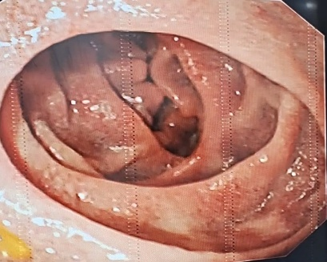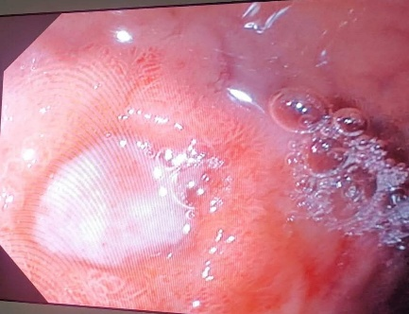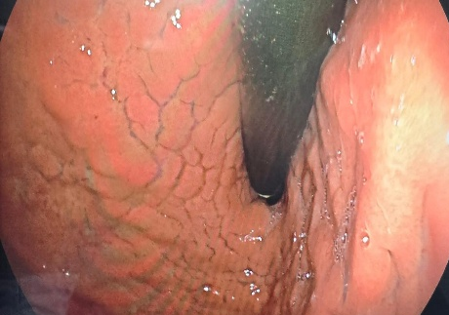
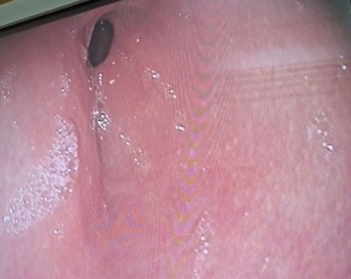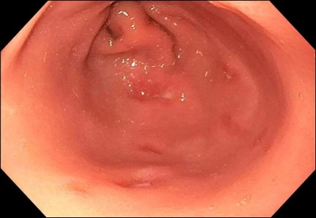
Image A duodenal hyperaemia
Image B duodenal bulb ulcer clean base and erosions
Image c hypertrophied mucosa
Image D gastric hyperaemia
Image E gastric (antral) ulcers with clean base

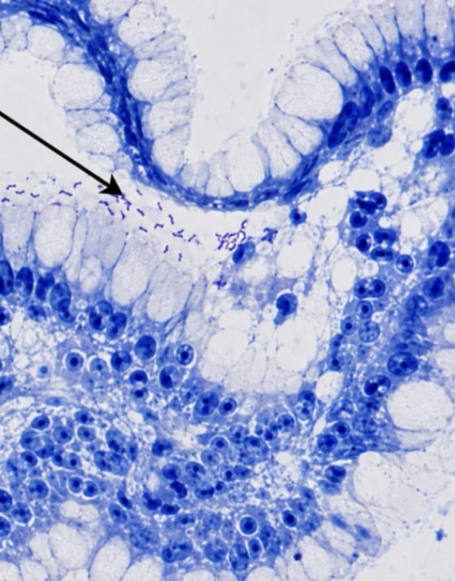
Image S4 shows H.pylori organisms by Giemsa stain (arrow pointed)

